Name: Core: Week of: 1/13/20 – 1/17/20
Week-By-Week
Calculator Inactive: Please show ALL your work and circle your final answer! Thanks!
1.) What is the value of  ($6^{2}$ – 10) ÷ 5 × $2^{5}$ | 2.) Jewel will cut a piece of ribbon that is 3$\frac{2}{5}$ feet long into $\frac{1}{10}$ – foot sections. How many sections will result?
3.) If gas costs $2.45 a gallon, how much would it cost to purchase 14.5 gallons of gas? | 4.) During a Holiday Sale, the manager of a Defy Gravity gave away gift cards to every 45th person who visited.  - On Friday, 1,315 people visited.  - On Saturday, 1,645 people visited.  How many people received a gift card?
Calculator Active: Please use a calculator, circle your final answer, and show any work necessary for you to be able to check your work.
5.) Jenny has finished 14 of the 20 lessons in her piano book. Liam has finished the same percent of lessons from his piano book. His book contains 30 lessons. How many lessons has Liam finished? | 6.) Ryan is building a tree house. It will take $95\frac{1}{4}$hours to complete. He can work on the tree house $12\frac{1}{2}$ hours each week. To the nearest tenth, how many weeks will it take Ryan to complete the tree house?
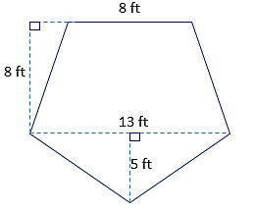  7.) What is the area of the pentagon shown below? | 8.) Eighty-five 6th-grade students chose to watch a movie on the last day of school. This is 25% of the 6th-grade class. How many total students are in the 6th grade?
9.) A store sells cans of tomatoes priced as shown. Which size can of tomatoes has the lowest cost per ounce?  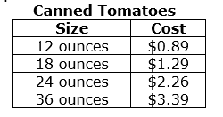 | 10.) Sarah earns $600 per week and spends 15% of her earnings on transportation. How much does Sarah spend on transportation every week?

