Name: Core: Week of: 1/21/20 – 1/24/20
Week-By-Week
Calculator Inactive: Please show ALL your work and circle your final answer! Thanks!
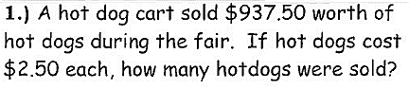 | 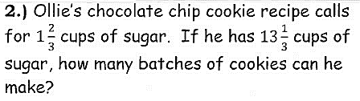
3.) Multiply: 4.321 ∙ 7.89 | 4.) Divide: 21.35 ÷ 3.5
Calculator Active: Please use a calculator, circle your final answer, and show any work necessary for you to be able to check your work.
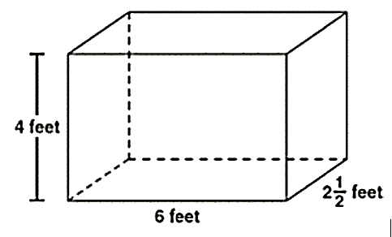  5.) How many cubes with the side length of ½ foot will fit inside the rectangular prism below? | 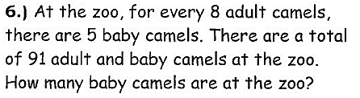
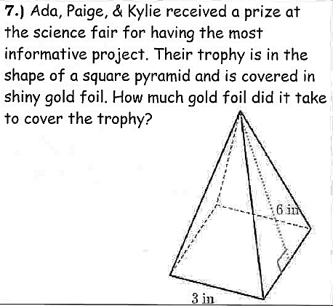 | 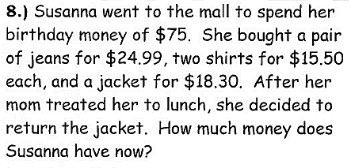
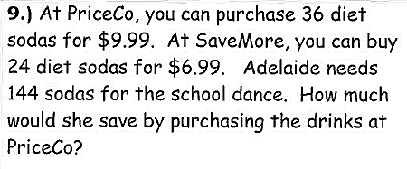 | 10.) Sam is using the expression $\frac{m}{4n}$ in class. What is the value of the expression when m = 6 and n = $\frac{1}{2}$ ?

