Name: Core: Week of: 1/27/20 – 1/31/20
Week-By-Week
Calculator Inactive: Please show ALL your work and circle your final answer! Thanks!
3.) What is 830.94 ÷ 13.2 ? | 4.) Ashton’s family is taking a road trip. If they drive at a speed of 74 mph for 8.25 hours, how far will they have gone?
Calculator Active: Please use a calculator, circle your final answer, and show any work necessary for you to be able to check your work.
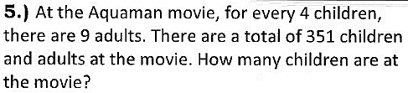
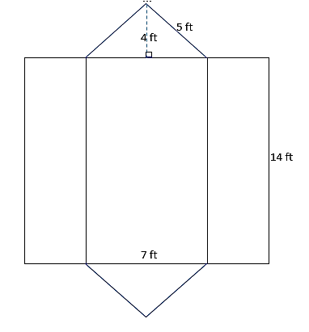
7.) What is the surface area of the three-dimensional figure below?

