Name: Core: Week of: 2/3/20 – 2/7/20
Week-By-Week
Calculator Inactive: Please show ALL your work and circle your final answer! Thanks!
1.) What is the value of  ($5^{3}$ – 15) ÷ 5 × $3^{2}$? | 2.) What is the value of  ${\left(6r+ \frac{1}{6}\right)}^{2}$ when r = 0?
3.) Patty had a job during summer vacation. She earned $7.25 per hour. She worked 15 hours per week for 6 weeks. How much money did Patty earn? | 4.) Solve: 775 ÷ 62
Calculator Active: Please use a calculator, circle your final answer, and show any work necessary for you to be able to check your work.
5.) Jim will go fishing 24 days this month. If a monthly pass is $44 and a day pass is $3, how much money will he save this month if he buys the monthly pass instead of individual day passes? | 6.) Find the surface area of the prism below.  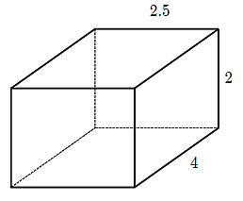
7.) Find the surface area of the triangular prism below.  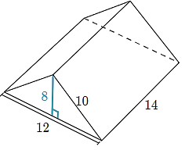 | 8.) What is the value of x when $\frac{1}{4}$x = 6$\frac{1}{4}$ ?
9.) Of a squirrel's hidden nuts, for every 15 that get found, there are 13 that do not get found. A squirrel hid 196 nuts all together. How many are never found? | 10.) John is a quarterback. This year, he completed 350 passes, which is 70% of all the passes he's thrown this year. How many total passes has John thrown this year?

