Name: Core: Week of: 2/10/20 – 2/14/20
Week-By-Week
Calculator Inactive: Please show ALL your work and circle your final answer. Be sure to explain your answer for #3 & #4 with at least 1 complete sentence.
1.) What is the value of  ${(7x+ \frac{1}{4})}^{3}$ when x = 0? | 2.) Mrs. Clark bought gas for her mini van at the new Sheetz station in Raleigh. If gas cost $1.98 per gallon, how much did she pay to fill up the 21.6 gallon tank? (Round your answer to the nearest penny)
3.) Tonya pays $375 each month to rent an office where she earns $30 per hour  tutoring students. Which equation represents Tonya’s profit (earnings after her expenses), y, for working  x hours?  - y = 30 + 375x  - y = 30x + 375  - y = 30 – 375x  - y = 30x – 375  Explain your answer choice below: | 4.) Which expression is equivalent to  35x – 20y?  - 5(7x + 4y)  - 5(7x – 20y)  - 5(7x + 20y)  - 5(5x – 4y)  Explain your answer choice below:
Calculator Active: Please use a calculator, circle your final answer, and show any work necessary for you to be able to check your work.
5.) Rachael is building a canoe It will take $115\frac{1}{4}$hours to complete. She can work on the canoe $9\frac{1}{2}$ hours each week. To the nearest tenth, how many weeks will it take Rachael to complete the canoe? | 6.) Ben is building a model of a skyscraper with centimeter cubes but is having some trouble. He knows the model should have a volume of 510 cm³ and that the area of the base is 30 cm². How many layers high will he need to create his model?
7.) Combine the like terms to simplify this expression. $5t+6+2r+9t+10+3r+2$ | 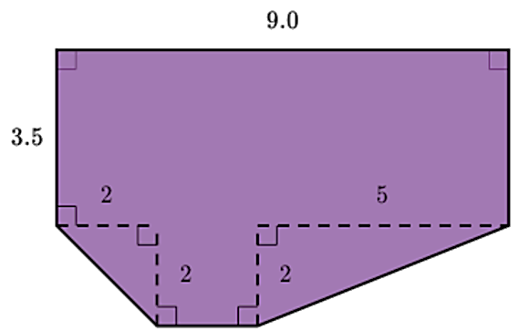  8.) Find the area of the shape below.
9.) Find the value if y = 3 and x = 2.  $3y^{2}+5y+xy-8$ | 10.) Joe has finished 14 of the 30 lessons in his piano book. Lindsey has finished the same percent of lessons from her piano book, but her book contains 45 lessons. How many lessons has Lindsey finished?

